PERSONAL DETAILS
Photo
NAME
JOB TITLE
ORGANISATION
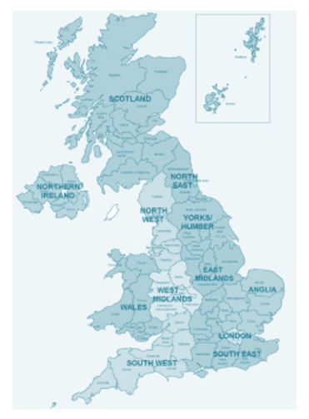
LOCATION Please select one from the option below
☐ London |  | ☐ North-West
☐ South-East |  | ☐ North-East
☐ South-West |  | ☐ Yorkshire & Humber
☐ East Anglia |  | ☐ Scotland
☐ East Midlands |  | ☐ Wales
☐ West Midlands |  | ☐ Northern Ireland
BRIEF WORK HISTORY Provide details of roles that you have held and what they entailed
MENTORING FOCUS Provide details of any areas/themes in which you could focus your mentoring
SKILLS AND EXPERIENCE Detail any relevant experience that would make you a good mentor?
MOTIVATIONS Why do you want to be an AVM Mentor? What do you want to gain from the programme?
WHAT IS IMPORTANT TO ME? These could be people, values or hobbies/interests
WHAT DO PEOPLE LIKE ABOUT ME? What do others say are your positive qualities?
WHY CHOOSE YOU? What can you offer a mentee? What would make you a good mentor?
HOW BEST TO CONNECT WITH ME? State your preferred means of communication e.g. phone, email, Skype?
PREFERRED TIMES / LOCATION Are there any days / times that you are unable to do?
AN INTERESTING FACT ABOUT ME… Something that people might not know!

